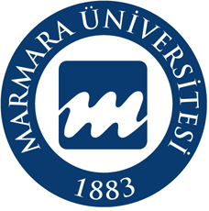

Marmara University
Faculty of Engineering
Department of Metallurgical and Materials Engineering

MSE 4098/4198
PROJECT TIME EXTENSION FORM
Project No:
Project Title:
Consider the time you will need to devote to editing your thesis if it contains any structural mistakes, a significant percentage of plagiarism, etc. However, if your thesis acceptance is delayed and you miss the faculty graduation dates, neither the department administration nor the department graduation panel will take responsibility.

PLEASE WRITE THE REASONS FOR NOT SUBMITTING YOUR PROJECT ON TIME DETAILLY.

Project Team  Members | Name-Surname Signature  1)  2)  3)  4)  5)  6)
Advisor | Name-Surname Date Signature

